training 1 epoch...

53.78077054023743 seconds used......

1 training finished! average train loss: 0.6794931927140344

evaluating...

Confusion matrix, without normalization

[[ 239 34 21]

[ 878 2810 133]

[ 46 11 785]]

Normalized confusion matrix

[[0.81292517 0.11564626 0.07142857]

[0.22978278 0.73540958 0.03480764]

[0.05463183 0.01306413 0.93230404]]

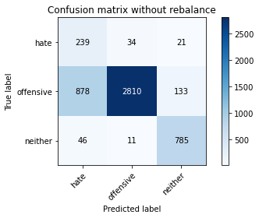

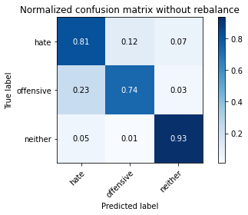

precision recall f1-score support

hate 0.21 0.81 0.33 294

offensive 0.98 0.74 0.84 3821

neither 0.84 0.93 0.88 842

accuracy 0.77 4957

macro avg 0.68 0.83 0.68 4957

weighted avg 0.91 0.77 0.82 4957

average eval_loss: 0.5278301920370393, accuracy: 0.7734516844865846

training 2 epoch...

53.146252155303955 seconds used......

2 training finished! average train loss: 0.4121247288166431

evaluating...

Confusion matrix, without normalization

[[ 246 40 8]

[ 909 2869 43]

[ 186 34 622]]

Normalized confusion matrix

[[0.83673469 0.13605442 0.02721088]

[0.23789584 0.75085056 0.0112536 ]

[0.22090261 0.04038005 0.73871734]]

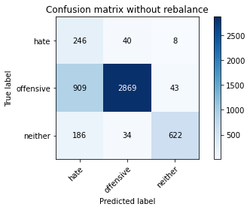

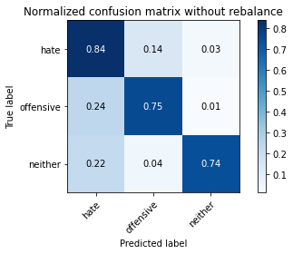

precision recall f1-score support

hate 0.18 0.84 0.30 294

offensive 0.97 0.75 0.85 3821

neither 0.92 0.74 0.82 842

accuracy 0.75 4957

macro avg 0.69 0.78 0.66 4957

weighted avg 0.92 0.75 0.81 4957

average eval_loss: 0.5417658516917704, accuracy: 0.7538833972160581

training 3 epoch...

53.14321446418762 seconds used......

3 training finished! average train loss: 0.2937818235685036

evaluating...

Confusion matrix, without normalization

[[ 232 44 18]

[ 820 2876 125]

[ 34 15 793]]

Normalized confusion matrix

[[0.78911565 0.14965986 0.06122449]

[0.21460351 0.75268254 0.03271395]

[0.04038005 0.01781473 0.94180523]]

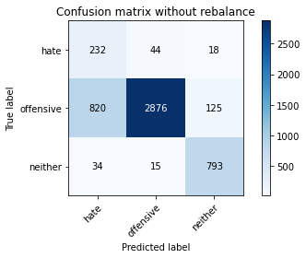

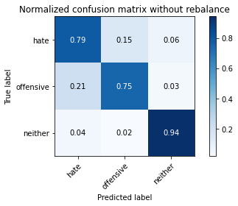

precision recall f1-score support

hate 0.21 0.79 0.34 294

offensive 0.98 0.75 0.85 3821

neither 0.85 0.94 0.89 842

accuracy 0.79 4957

macro avg 0.68 0.83 0.69 4957

weighted avg 0.91 0.79 0.83 4957

average eval_loss: 0.5338457700349053, accuracy: 0.7869679241476699

training 4 epoch...

53.327207803726196 seconds used......

4 training finished! average train loss: 0.20686922804860955

evaluating...

Confusion matrix, without normalization

[[ 217 62 15]

[ 519 3192 110]

[ 41 25 776]]

Normalized confusion matrix

[[0.73809524 0.21088435 0.05102041]

[0.13582832 0.83538341 0.02878828]

[0.04869359 0.02969121 0.9216152 ]]

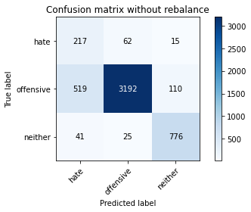

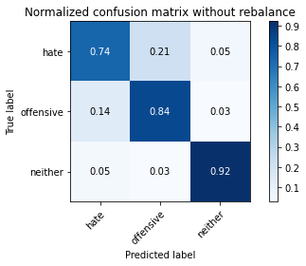

precision recall f1-score support

hate 0.28 0.74 0.41 294

offensive 0.97 0.84 0.90 3821

neither 0.86 0.92 0.89 842

accuracy 0.84 4957

macro avg 0.70 0.83 0.73 4957

weighted avg 0.91 0.84 0.87 4957

average eval_loss: 0.4330156678530835, accuracy: 0.8442606415170466

training 5 epoch...

53.37208318710327 seconds used......

5 training finished! average train loss: 0.13942155597339334

evaluating...

Confusion matrix, without normalization

[[ 232 48 14]

[ 766 2897 158]

[ 68 15 759]]

Normalized confusion matrix

[[0.78911565 0.16326531 0.04761905]

[0.20047108 0.75817849 0.04135043]

[0.0807601 0.01781473 0.90142518]]

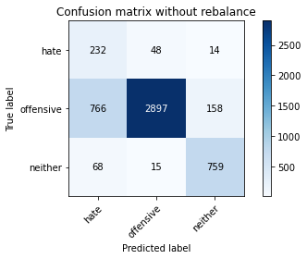

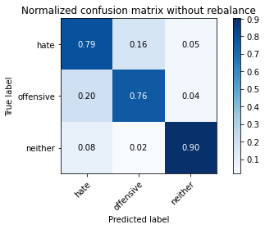

precision recall f1-score support

hate 0.22 0.79 0.34 294

offensive 0.98 0.76 0.85 3821

neither 0.82 0.90 0.86 842

accuracy 0.78 4957

macro avg 0.67 0.82 0.68 4957

weighted avg 0.91 0.78 0.82 4957

average eval_loss: 0.5802977759379815, accuracy: 0.7843453701835787

training 6 epoch...

53.216312408447266 seconds used......

6 training finished! average train loss: 0.08282086144307661

evaluating...

Confusion matrix, without normalization

[[ 219 57 18]

[ 697 3011 113]

[ 41 39 762]]

Normalized confusion matrix

[[0.74489796 0.19387755 0.06122449]

[0.18241298 0.78801361 0.02957341]

[0.04869359 0.04631829 0.90498812]]

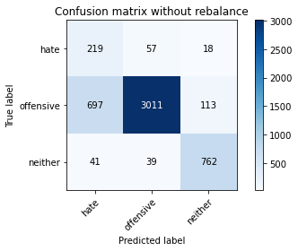

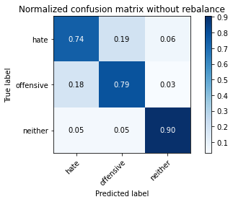

precision recall f1-score support

hate 0.23 0.74 0.35 294

offensive 0.97 0.79 0.87 3821

neither 0.85 0.90 0.88 842

accuracy 0.81 4957

macro avg 0.68 0.81 0.70 4957

weighted avg 0.91 0.81 0.84 4957

average eval_loss: 0.6972464345500374, accuracy: 0.8053258018963082

training 7 epoch...

53.20469903945923 seconds used......

7 training finished! average train loss: 0.05829580789411506

evaluating...

Confusion matrix, without normalization

[[ 232 51 11]

[ 842 2899 80]

[ 72 37 733]]

Normalized confusion matrix

[[0.78911565 0.17346939 0.03741497]

[0.22036116 0.75870191 0.02093693]

[0.08551069 0.04394299 0.87054632]]

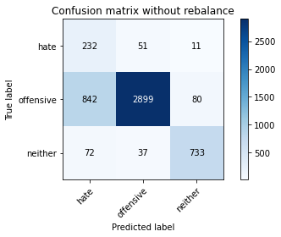

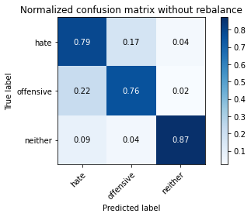

precision recall f1-score support

hate 0.20 0.79 0.32 294

offensive 0.97 0.76 0.85 3821

neither 0.89 0.87 0.88 842

accuracy 0.78 4957

macro avg 0.69 0.81 0.68 4957

weighted avg 0.91 0.78 0.83 4957

average eval_loss: 0.823456041107244, accuracy: 0.7795037320960259

training 8 epoch...

53.366753339767456 seconds used......

8 training finished! average train loss: 0.04846126513592409

evaluating...

Confusion matrix, without normalization

[[ 223 57 14]

[ 584 3139 98]

[ 43 41 758]]

Normalized confusion matrix

[[0.7585034 0.19387755 0.04761905]

[0.15283957 0.82151269 0.02564774]

[0.05106888 0.04869359 0.90023753]]

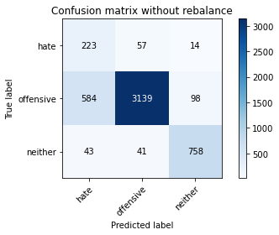

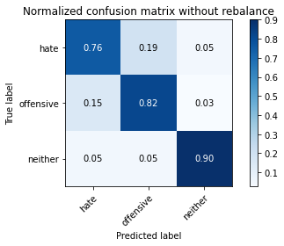

precision recall f1-score support

hate 0.26 0.76 0.39 294

offensive 0.97 0.82 0.89 3821

neither 0.87 0.90 0.89 842

accuracy 0.83 4957

macro avg 0.70 0.83 0.72 4957

weighted avg 0.91 0.83 0.86 4957

average eval_loss: 0.6396780917760382, accuracy: 0.8311478716965907

training 9 epoch...

53.27726078033447 seconds used......

9 training finished! average train loss: 0.028639637920270234

evaluating...

Confusion matrix, without normalization

[[ 228 45 21]

[ 777 2906 138]

[ 46 23 773]]

Normalized confusion matrix

[[0.7755102 0.15306122 0.07142857]

[0.20334991 0.76053389 0.0361162 ]

[0.05463183 0.02731591 0.91805226]]

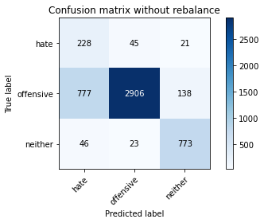

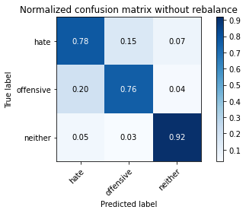

precision recall f1-score support

hate 0.22 0.78 0.34 294

offensive 0.98 0.76 0.86 3821

neither 0.83 0.92 0.87 842

accuracy 0.79 4957

macro avg 0.67 0.82 0.69 4957

weighted avg 0.91 0.79 0.83 4957

average eval_loss: 0.9272018156733274, accuracy: 0.7881783336695583

training 10 epoch...

53.21998119354248 seconds used......

10 training finished! average train loss: 0.024997028737663896

evaluating...

Confusion matrix, without normalization

[[ 216 58 20]

[ 666 3012 143]

[ 36 14 792]]

Normalized confusion matrix

[[0.73469388 0.19727891 0.06802721]

[0.17429992 0.78827532 0.03742476]

[0.04275534 0.01662708 0.94061758]]

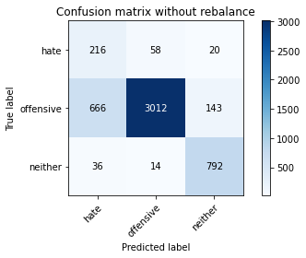

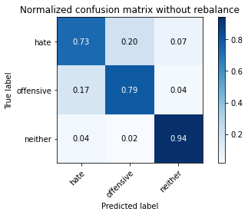

precision recall f1-score support

hate 0.24 0.73 0.36 294

offensive 0.98 0.79 0.87 3821

neither 0.83 0.94 0.88 842

accuracy 0.81 4957

macro avg 0.68 0.82 0.70 4957

weighted avg 0.91 0.81 0.84 4957

average eval_loss: 0.87309895666141, accuracy: 0.81097437966512